**DBMS FISAC**

**MongoDB**

**Dataset:**

Dataset choses, various observatories, with every document containing the Field Name, LaunchDate, Organization and submitted_by, with optional field Age.

**Dataset Chosen (in JSON format):**

**[**

**{**

**Name: "Chandra",**

**LaunchDate: "1999-07-23T00:00:00Z",**

**submitted_by: "230953450_priyanshnandan"**

**},**

**{**

**Name: "Euclid",**

**LaunchDate: "2023-07-01T00:00:00Z",**

**Organization: "ESA",**

**Age: 2,**

**submitted_by: "230953450_priyanshnandan"**

**},**

**{**

**Name: "Fermin Gamma-Ray space telescope",**

**LaunchDate: "2008-06-11T00:00:00Z",**

**Organization: "NASA",**

**Age: 17,**

**submitted_by: "230953450_priyanshnandan"**

**},**

**{**

**Name: "XMM Newton",**

**LaunchDate: "1999-12-10T00:00:00Z",**

**Organization: "ESA",**

**Age: 25,**

**submitted_by: "230953450_priyanshnandan"**

**},**

**{**

**Name: "TESS",**

**LaunchDate: "2018-04-18T00:00:00Z",**

**Organization: "NASA",**

**Age: 7,**

**submitted_by: "230953450_priyanshnandan"**

**},**

**{**

**Name: "NEOWISE",**

**LaunchDate: "2009-12-14T00:00:00Z",**

**Organization: "NASA",**

**submitted_by: "230953450_priyanshnandan"**

**},**

**{**

**Name: "NICER",**

**LaunchDate: "2017-06-03T00:00:00Z",**

**Age: 7,**

**Organization: "NASA",**

**submitted_by: "230953450_priyanshnandan"**

**},**

**{**

**Name: "XRISM",**

**LaunchDate: "2023-09-06T00:00:00Z",**

**Age: 2,**

**Organization: "NASA",**

**submitted_by: "230953450_priyanshnandan"**

**},**

**{**

**Name: "NuSTAR",**

**LaunchDate: "2012-06-13T00:00:00Z",**

**Age: 13,**

**Organization: "NASA",**

**submitted_by: "230953450_priyanshnandan"**

**},**

**{**

**Name: "James Webb Telescope",**

**LaunchDate: "2021-12-25T00:00:00Z",**

**Age: 4,**

**Organization: "NASA",**

**submitted_by: "230953450_priyanshnandan"**

**}**

]

**Creating Database and Collection**

Using the command

use 230953450_DB

We create the database, since the database is not available, it creates a database for the same, and switches to it

Now, we create the collection using the command

db.createCollection(“230953450_Collection”)

Using the command,

Show dbs

We can see, the new database created

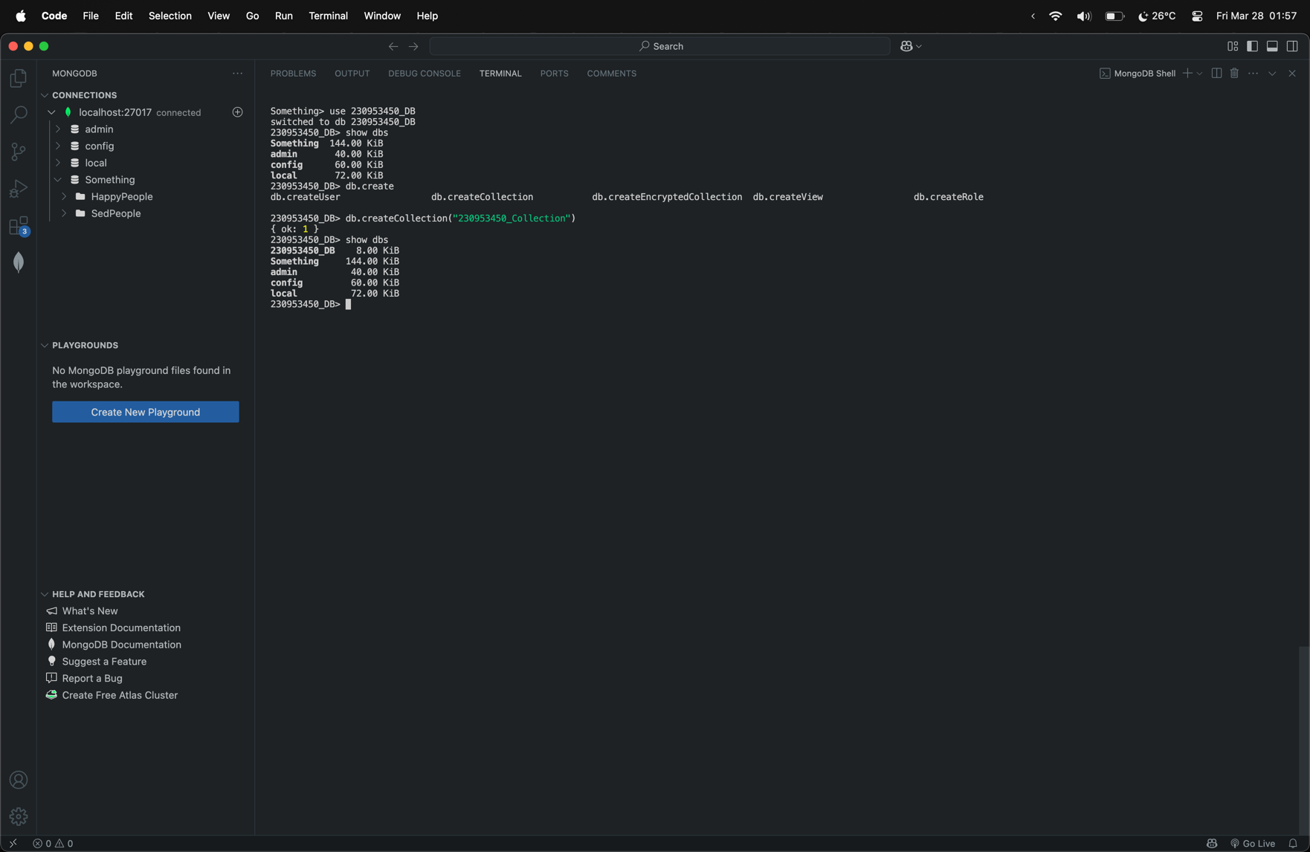

**Note:** MongoDB will not display an empty database, that’s why only after creating the collection, we can see the database.

**Inserting Documents into the collection**

We insert 10 documents, using insertOne and insertMany commands

**Note:** Current insertion lacks the field submitted_by, it will be update later

**insertOne**

**db.getCollection("230953450_Collection").insertOne({Name: "Chandra", LaunchDate: new Date("1999-07-23")})**

**db.getCollection("230953450_Collection").insertOne({Name: "NICER", LaunchDate: new Date("2017-06-03"), Age: 7, Organization: "NASA"})**

**db.getCollection("230953450_Collection").insertOne({Name: "XRISM", LaunchDate: new Date("2023-09-06"), Age: 2, Organization: "NASA"})**

**db.getCollection("230953450_Collection").insertOne({Name: "NuSTAR", LaunchDate: new Date("2012-06-13"), Age: 13, Organization: "NASA"})**

**db.getCollection("230953450_Collection").insertOne({Name: "James Webb Telescope", LaunchDate: new Date("2021-12-25"), Age: 4, Organization: "NASA"})**

**insertMany**

**db.getCollection("230953450_Collection").insertMany([{Name: "Euclid", LaunchDate: new Date("2023-07-01"), Organization: "ESA", Age: 2}, {Name: "Fermin Gamma-Ray space telescope", LaunchDate: new Date("2008-06-11"), Organization: "NASA", Age: 17}, {Name: "XMM Newton", LaunchDate: new Date("1999-12-10"), Organization: "ESA", Age: 25}, {Name: "TESS", LaunchDate: new Date("2018-04-18"), Organization: "NASA", Age: 7}, {Name: "NEOWISE", LaunchDate: new Date("2009-12-14"), Organization: "NASA"}])**

**Note:** here, we use

**db.getCollection(“230953450_Collection”)**

for accessing the collections as we cannot use special characters in the naming convention generally, if it was not the case, we would have accessed the collection using the command

**db.CollectionName**

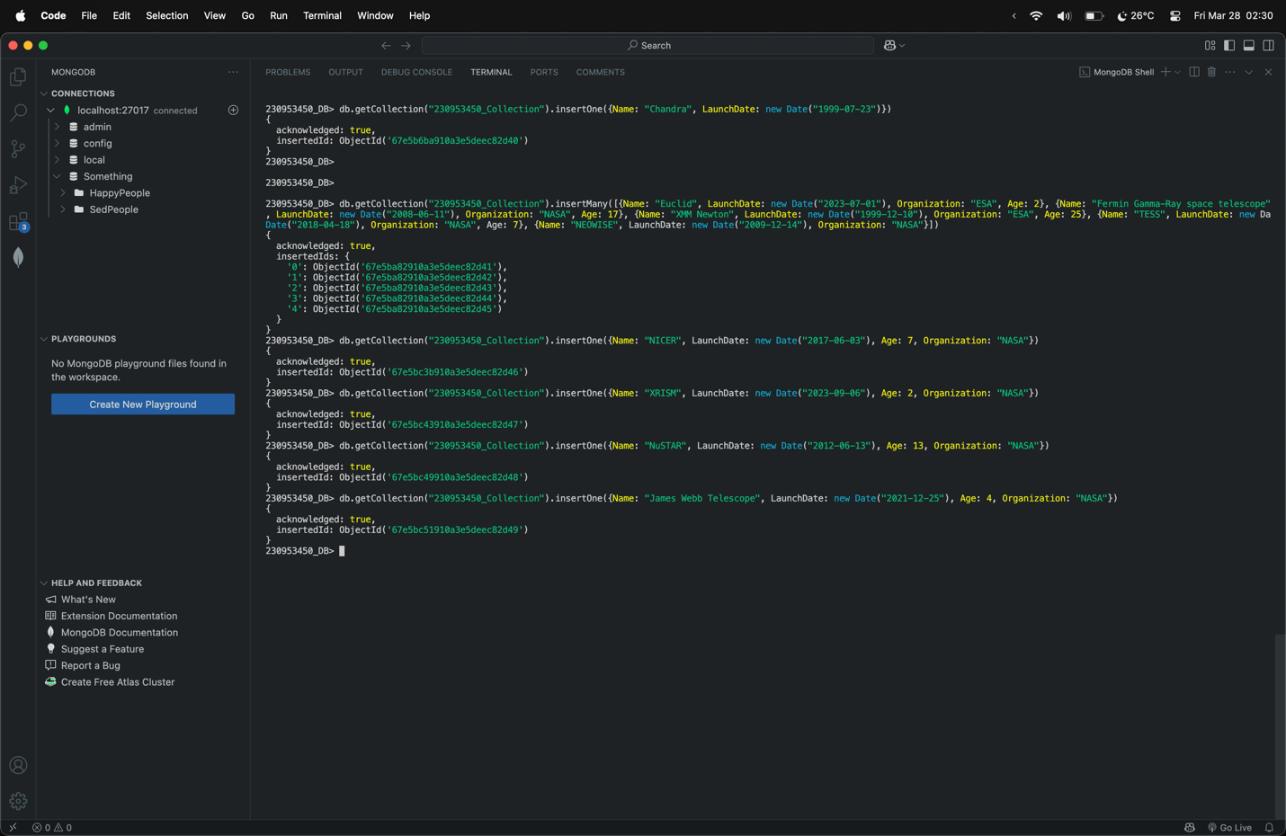

**Query Execution**

* **Retrieve all the information**

**db.getCollection(“230953450_Collection”).find()**

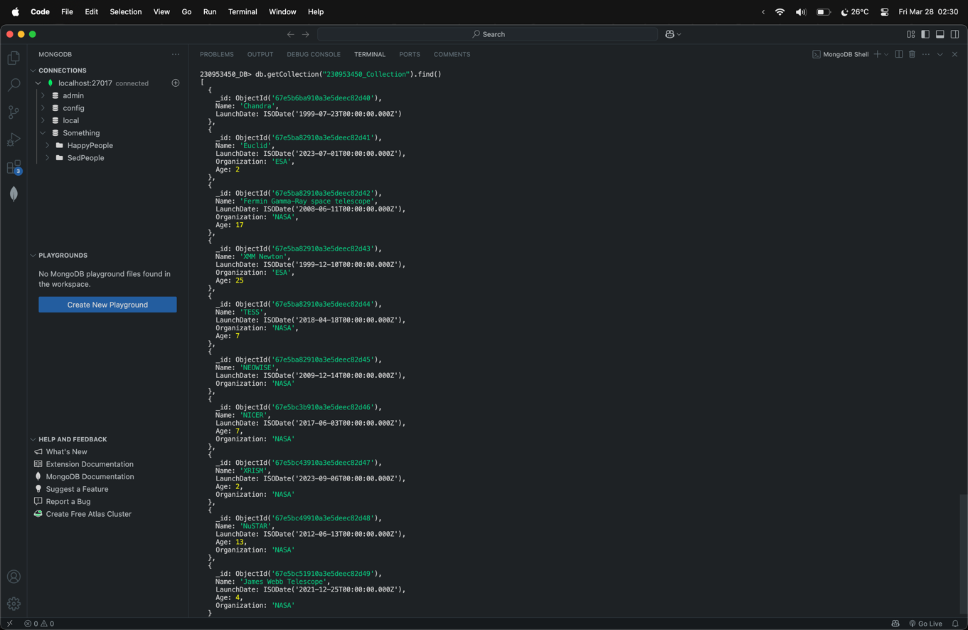

* **Filtering**

**Question-> Display all the Telescopes belonging to ESA.**

**db.getCollection("230953450_Collection").find({Organization: “ESA”})**

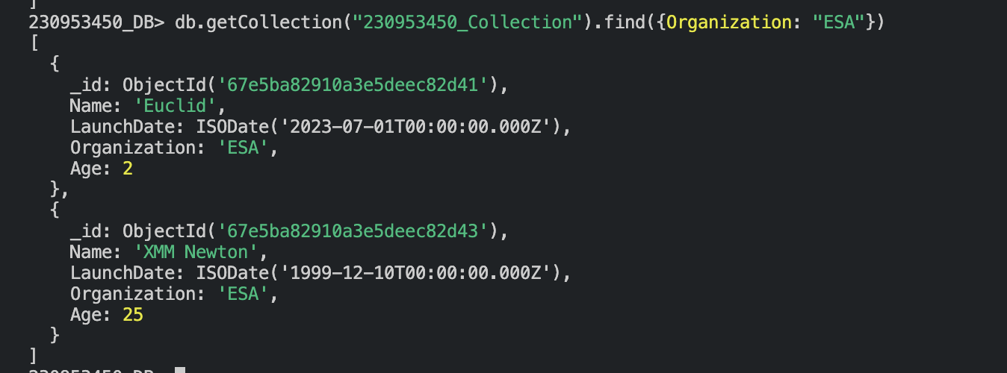

* **Sorting**

**Question-> Display all the Telescopes from newest to the oldest telescope**

**db.getCollection("230953450_Collection").find().sort({age: 1})**

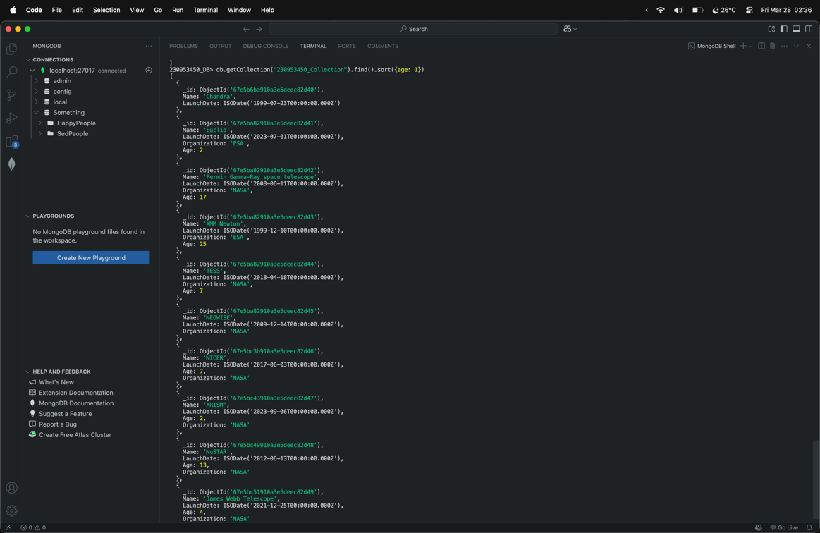

* **Projection**

**Question-> Display Names of all the telescopes**

**db.getCollection("230953450_Collection").find({},{Name: true, _id: false})**

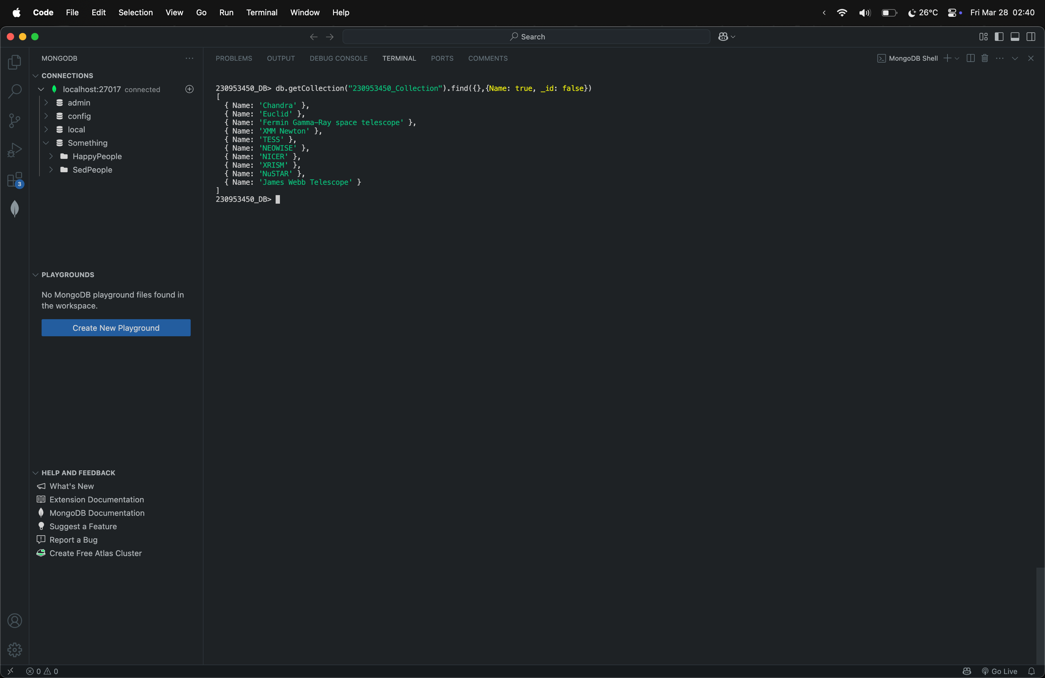

* **Aggregation Queries**

**Question-> Display Names of all the telescopes belonging to NASA**

**db.getCollection("230953450_Collection").find({Organization: "NASA"},{Name: true, _id: false})**

**Question-> Display Names of all the telescopes belonging to NASA in descending order of their names**

**db.getCollection("230953450_Collection").find({Organization: "NASA"},{Name: true, _id: false}).sort({Name: -1})**

**Question-> Display the NASA telescope with the name that comes last alphabetically**

**db.getCollection("230953450_Collection").find({Organization: "NASA"},{Name: true, _id: false}).sort({Name: -1}).limit(1)**

* **Updating documents**

**updateMany()**

**Question-> Add the field submitted_by if it doesn’t exist already, set the value of the field to “230953450_priyanshnandan”**

**db.getCollection("230953450_Collection").updateMany({submitted_by: {$exists: false}},{$set: {submitted_by: "230953450_priyanshnandan"}})**

**Before Updating**

db.getCollection("230953450_Collection").find({},{_id: false})

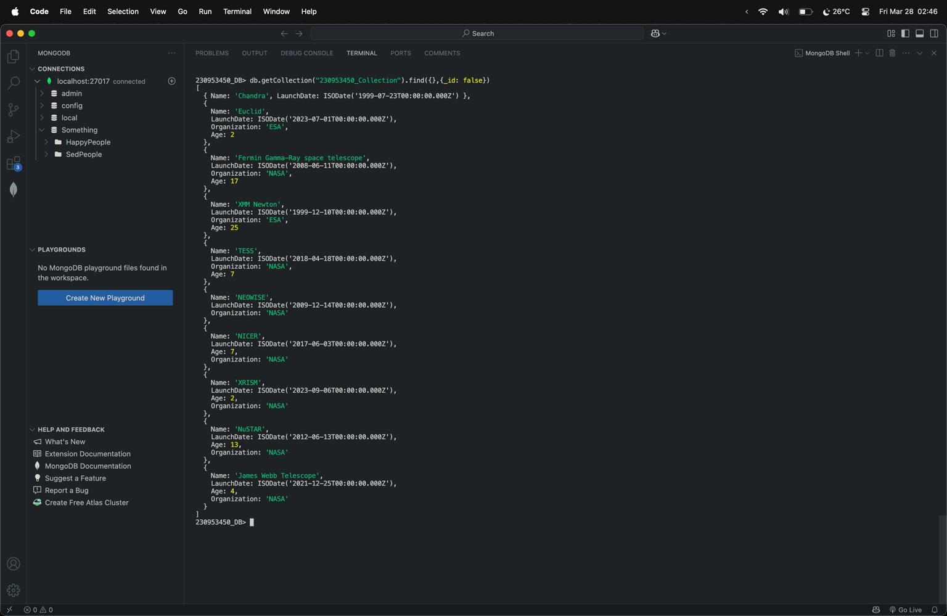

**After Updating**

db.getCollection("230953450_Collection").find({},{_id: false})

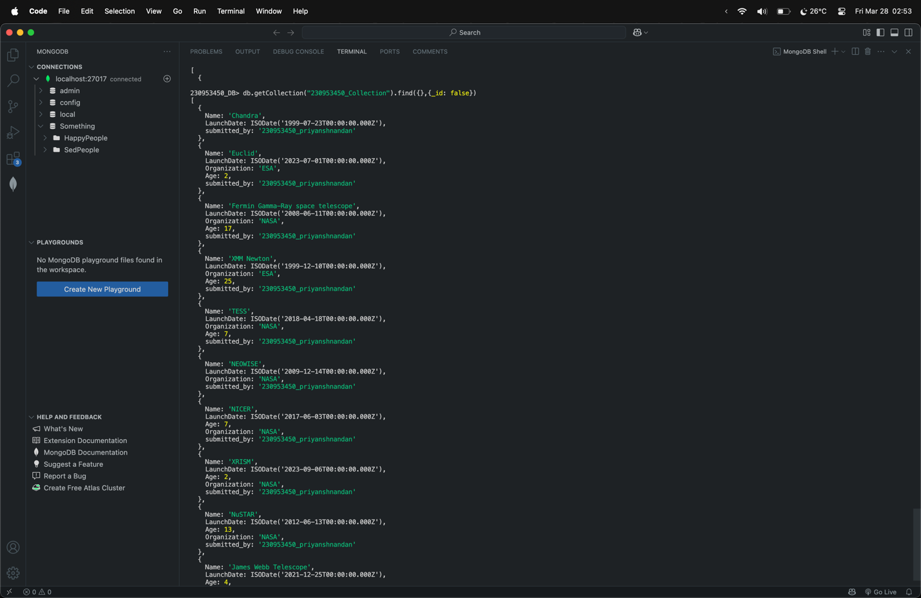

**updateOne()**

**Question-> Update the age of NICER telescope to 6.**

**db.getCollection("230953450_Collection").updateOne({Name: "NICER"},{$set: {Age: 6}})**

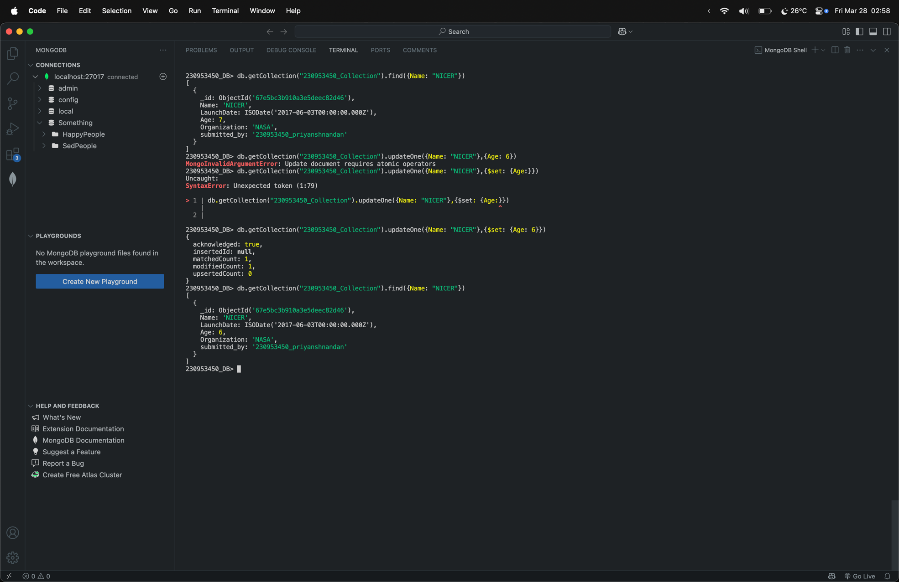

* **Deleting documents**

**deleteMany()**

**Question-> Delete all the Telescopes belonging to ESA.**

db.getCollection("230953450_Collection").find({Organization: "ESA"},{_id: false, Name: true})

**db.getCollection("230953450_Collection").deleteMany({Organization: "ESA"})**

db.getCollection("230953450_Collection").find({Organization: "ESA"},{_id: false, Name: true})

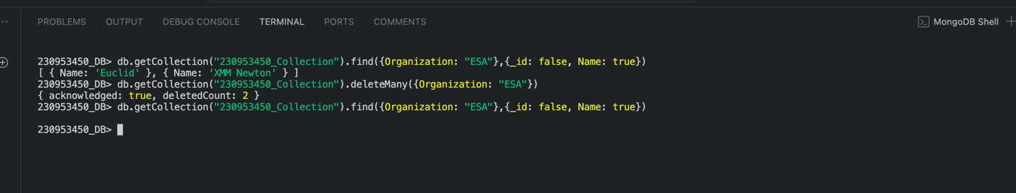

**deleteOne()**

**Question-> Delete TESS from the DB.**

**db.getCollection("230953450_Collection").deleteOne({Name: "TESS"})**

